**INVESTIGATION – INVESTING IN THE 21st CENTURY**

Jamie Coulson

**Investigation Organizer**

**Analyzing my task – a checklist**

What are the objectives of this investigation (what do I need to do?)

**The aim of this assignment is for me to create a investment strategy and to research two different companies on the stock market. This will broaden my understanding of strategy and forms of investment on the stock market.**

What are the key words/terms of the task?

**Part One:**

**To formulate a $1,000,000 investment strategy for a high net worth client who wants no more than 20% to be in cash and government bond, no more than 50% to be invested overseas, must invest on more than four different companies and no more than six, no investments in the mining sector stocks or bonds in Australia and no investments that are unethical.**

**Part Two:**

**To analyse two separate companies on the Australian Stock Exchange and write a summary about the companies.**

Where can I find information to complete my task?

**I can find the majority of information in order to complete this task on the ASX (Australian Stock Exchange) and other associated websites that allow for me to record and analyze a vast amount of stocks on the stock market. If have a specific question that I need answering and I cannot find the answer to it by myself I will ask Mr. Kandiah as he will be able to answer the majority of questions I ask him.**

What will my final presentation be?

**The final presentation will be an investment strategy report and a 2-page analysis of 2 current ASX stocks.**

What do I have to hand in with the final copy?

**I will hand in both the part 1 and 2 of the assignment along with references.**

**Thinking & Questioning**

**Use the next page to start to THINK about the variety of investments around?**

**Q1. As an investor, what are some of the investments are you able to invest in?**

**I am able to invest in:**

**- Government Bonds**

**- Currency**

**- Stocks**

**- Bonds**

**- Overseas companies**

**Q2. What are some examples of shares I can invest in the ASX?**

**DME, Dominos Pizza Enterprise Limited, $66.540, Consumer Services**

**BHP, BHP Billiton Limited, 23.630, metals and mining**

**WLP, Woodside Petroleum Limited, 32.630, Energy**

**CTX, Caltex Australia Limited, 32.750, Energy**

**STO, Santos Limited, 3.660, Energy**

**Q3. What are some possible reasons why a share price could move?**

**A share price could fluctuate because of the increase/decrease in the company’s total net worth which would influence value of a single stock because a stock is a set portion of a company. The portion of the company represented by the stock can never change. A company’s total net worth can be influenced by many events like the successful release of a new product would increase the total net worth of the company and therefore increase the worth of a single stock. A company’s net worth could also be negatively affected by events like an unsuccessful release of a product which would decrease the company’s total net worth and therefore decrease the value of a single stock.**

**Q4. What does the concept of ethical investing entail?**

**The concept of ethical investing is the act of only investing in products/companies that provide ethical services such as clean energy, sustainable solutions and medical solutions. These products do not have a substantial negative affect on the majority areas of the world, and therefore by investing in these they are not supporting a company that has a substantial negative impact on the majority of areas of the world. An example of unethical investing would be if someone invested in a company that produced guns or abused human rights and therefore the investor would be supporting a company that have a heavy negative impact on areas of the world**

**FOCUS QUESTIONS**

Great focus questions will help you to structure your assessment. Use your notes in this Organiser and the task sheet to help you create some questions that can guide your investigation.

Once you find the answers to your questions you will be able to write your assessment. Remember to use who, what, why, when, where and how?). To help formulate your questions, create a brainstorm below.

Research Notes

At the top of each page write down a focus question that you want to answer. As you research your question, write down the answer to your question **in your own words.** Always write down the source of your information and use this information to create a bibliography for your finished assignment.

**Focus Question:**

What are some signs to look out for when choosing stocks to invest in.

**Author:** TheStreet

**Title:** 10 Questions to Ask Before You Buy a Stock

**Publisher:** TheStreet

**Website Address:**

https://www.thestreet.com/story/10139093/2/10-things-you-should-know-before-you-buy-a-stock.html

Notes:

* If a competitor of the business ‘s stock recently raised substantially the business could loss value.
* What is the companies previous history over the past year if they have held a consistent growth they will have a good statergy for this.
* If previous dividends were under what was forecasted it could mean the company is struggling.

**Focus Question:**

What is the current financial situation of the west Australian housing market?

**Author:** Emily Piesse

**Title:** WA housing prices to fall over supply hits

**Publisher:** ABC News, 22 May 2017

**Website Address:** http://www.abc.net.au/news/2017-03-21/wa-housing-prices-to-fall-as-oversupply-hits-state/8373564

**Notes:**

* BIS Oxford Economics show WA will have an extra 14,600 dwellings — relative to underlying demand — by the middle of the year, and an extra 17,500 dwellings by June 2018.
* The WA housing market decline is estimated to reach the bottom of its cycle by the second half of 2018.
* There has been an under supplied market 3 to 4 years ago. The population growth has gone from 3.5% to 1.3%. In that environment house prices plummeted.
* The WA housing market is expected to remain relatively soft until 2021, with an upturn in the following years

**Part One: Investment Stratergy**

**Investment Strategy**

I have selected four stocks with a mix a two stable companies, one offshore technology company and one Australian mid cap company with exposure to the east coast infrastructure projects.

**Wesfarmers Ltd (ASX:WES)**

Weighting: 25%

Wesfarmers in an Australian Conglomerate which owns a variety of businesses in many different sectors (ie insurance, food retail, hardware retail and other investements). This gives the company exposure to the Australian economy in a broader sense (they sell a lot of different products from insurance to groceries) as well the opportunity to take its successful business models (ie Bunnings) into different markets like the UK

Wesfarmers recently acquired HOMEBASE in the UK and have used it as a platform for the Bunnings business entry to the UK market. The expansion of the Bunnings business, if successful, will aid Wesfarmers financial growth and has also gained them access to a completely new market which they may roll other Wesfarmers business’s into, allowing for even more financial growth.

Given the success of the Bunnings business the expansion into the UK is considered reasonably low risk, this combined with the mature nature of the groups other businesses should allow it to maintain the current dividend policy and share price so I see it as a reasonable safe investment with some potential upside.

**Australian and New Zealand Banking Group (ASX:ANZ)**

Weighting: 25%

Australian and New Zealand Banking Group )”ANZ”) is the fourth largest bank by market capitalisation in Australia and is included in the Australian Government deposit guarantee scheme. The big four Australian banks are considered to have a protected market because the Government guarantee combined preferential treatment by the bank regulator (APRA) allows them to have a lower cost base than other international and smaller (ie Bank Of Queensland) Australian banks in the market and they are able to make greater profits that are passed onto shareholders.

The preferential regulatory regime also means that ANZ business is unlikely to be threatened by any emerging and disruptive business models (like the Uber has threatened the Taxi industry, the barriers to entering the Australian banking market are much higher so a banking equivalent of Uber is unlikely).

I don’t have any real preference for one of the big four banks over the other three, so I selected ANZ because I like blue.

**NVIDIA Corporation**

Weighting: 25%

NVIDIA Corporation is a Technology Design and Manufacturing company that mainly produces Graphics Processing Units (GPU) for the gaming and professional market. NVIDIA have a forecasted dividend of 0.50c for the next two year which represents a 22.78% increase of the dividend of the previous year.

The company recently released its new flagship GPU the GeForce GTX 1080 Ti which drastically increased the stock price of the company. Of specific interest to my investment decision is the company is expected to be releasing a new high end GTX Titan (NVIDIA’s most high end GPU unit) later this year. The new CPU is expected to increase the company’s sales significantly and should have a positive impact on its share price and dividend policy.

I like the exposure to the CPU industry because as companies become more and more reliant on software to preform everyday commands and tasks the need for more powerful computing systems will continue. NVIDIA’s technology should keep them at the forefront of the CPU industry, unless a disruptive technology enters the market. At the moment the technology industry is heavily reliant on current CPU technology so I don’t see the disruptive threat to be within my investment timeframe.

**Global Construction Services Limited**

Weighting: 25%

Global Construction Services Limited (GCS) is a construction company based in Perth specialising is formwork, laying of concrete structures.

Brookfield recently acquired 15% of GCS and have assisted them in acquire the similar formwork business on the east side of Australia to take advantage of the increased construction activity in those markets. Brookfields also owns Multiplex, a major Australian construction company that performs the major projects on the east coast. The theory is that Multiplex will award the formwork subcontracts to GCS instead of the other non-aligned formwork companies.

This will expand GCS’s markets for a product they are already very good at and should increase its sales, profits and dividends (and therefore its share price).

**Summary**

I have chosen to provide this investment strategy to my client as all investments fit within the given specification and from the research that I have presented I believe I have justified that investing in these companies will provide substantial profits to the client.

**Part Two : Analysis**

**NVIDIA Corporation (NVDA) Stock Analysis**

NVIDIA corporation is a business that designs and manufactures graphics processing units (GPU) for gaming and professional uses. A GPU is an extension of a computer that provides the computer with more processing power. NVIDIA Corporation’s primary market sector is Technology Hardware, Storage and Peripheral (45202030).

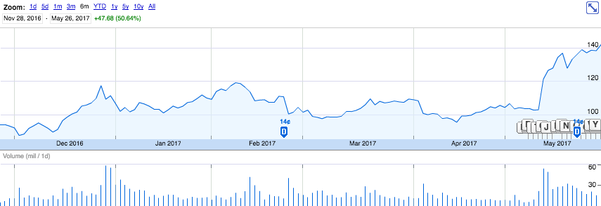NVIDIA was first listed on the stock exchange on the 22nd of January, 1999 and had a price on $1.64 (USD).

Figure NVIDIA Corporation's stock price over the past 6 months

From the beginning of the past 6 months on the 28th of November, 2016 till the 9th of May, 2017 NVIDIA’s stock price remained mostly static around the price of $109.45 with minor fluctuations in the price over the time period. (Figure 1) On the 10th of May, 2017 NVIDIA Corporation reported a stellar result for the fiscal 2018 Q1 and a driverless car deal with Toyota. The stock price increased from $102.94 to $121.29 the company then settled around $137.03. (Google, 2017)

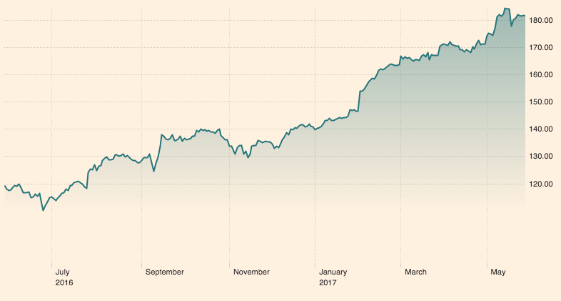

The sector that NVIDIA Corporation belongs to (Technology Hardware, Storage and Peripheral, 45202030) Has been on the stead rise over the past 12 months. The starting price was roughly $120 and has ended at roughly $180. This could be due to the increasing reliance of technological systems and the need for more powerful computer systems because of the increasing use of these systems. (The Financial Times, 2017)

Figure Technology Hardware, Storage and Peripheral (45202030) sector performance over the past year

**Atlassian Corporation PLC (TEAM) Stock Analysis**

Atlassian Corporation is a software development company that focuses on building programs that are used by software development teams to efficiently organize large teams of people and assign work for employees and also build software that can be used for programming software. The primary market sector that Atlassian Corporation focuses on is application software (45103010).

Atlassian Corporation was fist listed on the stock exchange in the 18th of December, 2015 and had an initial price of $27.50 (USD).

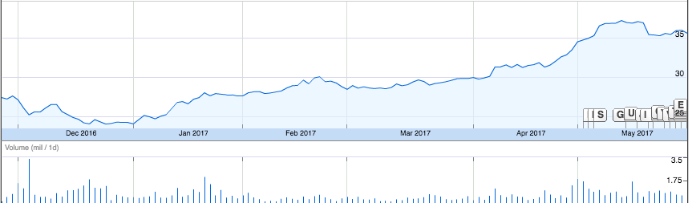Over the past six months Atlassian Corporation has displayed a consistent financial growth. Atlassian suffered a drop in share price at the beginning of the previous six months but then steadily recovered with a final financial growth of $8.16 (USD) or 26.76% (Figure 3) from the beginning of the previous six months. (Google, 2017)

Figure Graph of Atlassian Corporation’s stock price

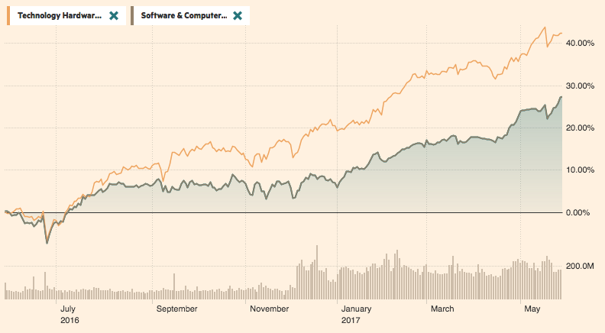The sector that Atlassian Corporation belongs to (Application Software (45103010)) has been steadily increasing over the past twelve months. The sector worth started at roughly $1,550 (USD) and has increased to a final price of $1,825.50 (USD). This is because of the increase in demand for more powerful Technology hardware and therefore the need for programs that can harness the hardware more efficiently, this relationship between the hardware and software industry can be seen on Figure 4 that graphs the financial growth of both the hardware and software sectors. (The Financial Times, 2017)

Figure 4 Graph comparing the financial growth of both the technology hardware and software sector

**BHP Billiton**

BHP Billiton (BHP) is a Global Resources Company. The Company is a producer of various commodities, including iron ore, metallurgical coal, copper and uranium. Its segments include Petroleum, Copper, Iron Ore and Coal. BHP belongs to the mining sector (151040).

BHP Billiton was listed on the Australian Stock Exchange (ASX) on the 1st of April, 1999 with an initial stock price of $13.565 (AUD).

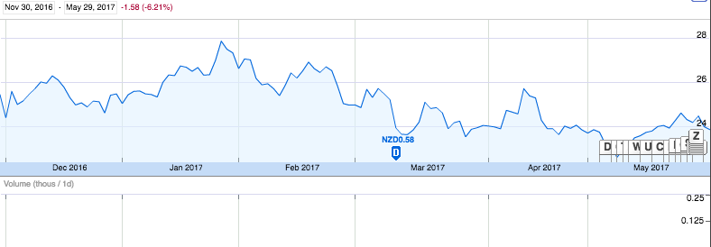

Over the past six months BHP Billiton has held a mainly static stock price but between the 6th of February, 2017 and the 27th of March, 2017 BHP Billiton’s stock price decreased by $2.41(AUD) during this period. Over the past six months BHP’s stock price decreased by $1.58 (AUD) or -6.21%. (Google, 2017)

Figure BHP's Stock price over the past six months

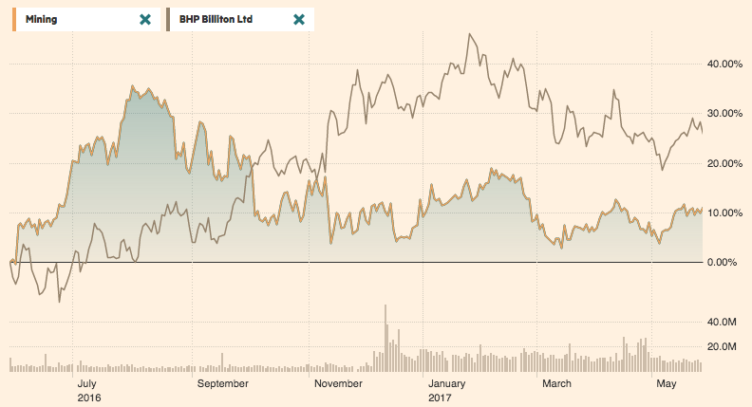

Figure Graph comparing the financial growth of the mining sector and BHP Billiton

BHP Billiton’s stock price has acted in the opposite way of how the mining sector has been fluctuating over the past year. Figure 5 graphs the financial growth of both the mining sector and BHP Billiton. As shown on the graph when the mining sectors economic growth decreases BHP’s financial growth increases. (The Financial Times, 2017)

**Wesfarmers Ltd**

Wesfarmers is an international conglomerate based in Perth, Australia. Wesfarmers Limited is engaged in various business operations, such as supermarkets, liquor, hotels and convenience stores; home improvement; office supplies, and an industrials division with businesses in chemicals, energy and fertilizers, industrial and safety products and coal. Wesfarmers is mainly focused on the market sector of Hypermarkets and Super Centers (30101040).

Wesfarmers Ltd was first registered on the Australian Stock Exchange on the 1st of April, 1999 and had an initial stock price of $15.091 (AUD).

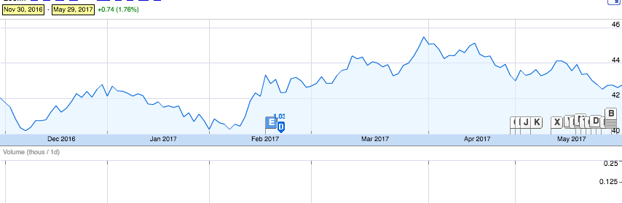Over the past six months Wesfarmers has only increased very slightly ($0.74 (AUD) 1.76%) and has held a primarily static stock price between the beginning and ending of the six months with a small increase on the 10th of February, 2017 (Figure 6) and then held a static price for the rest of the time period. (Google, 2017)

Figure 6 Graph of Wesfarmers stock price over the previous six months

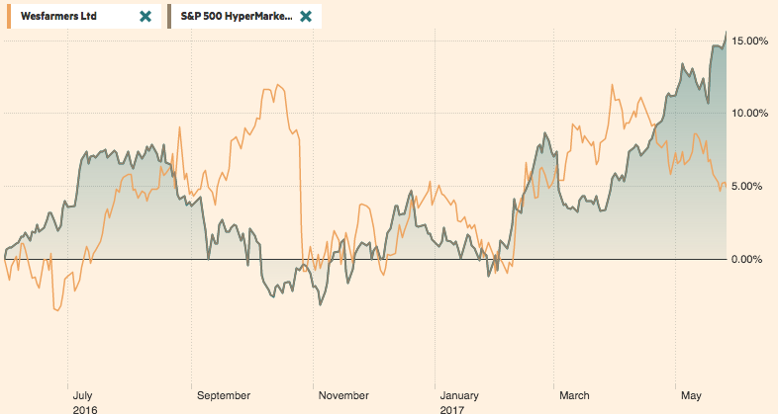Wesfarmers stock price has very roughly followed the general trend for the market. Figure 7 graphs the financial growth of both Wesfarmers and the Hypermarkets and Super Centers (30101040) sector. As shown on the graph Wesfarmers follows roughly the same pattern as the sector but between September and November Wesfarmers financial growth increased when the sectors financial growth decreased. (The Financial Times, 2017)

Figure Graph comparing the financial growth of both Wesfarmers and the 30101040 sector

**References**

Google. (2017, May 29). *Atlassian Corporation PLC*. Retrieved from Google Finance: https://www.google.com/finance?q=NASDAQ%3ATEAM&ei=or8rWdmdMoim0gSDuovIBw

Google. (2017, May 29). *BHP Billiton Limited*. Retrieved from Google: https://www.google.com/finance?q=ASX%3ABHP&ei=SpkrWajUJYqh0ASek5KwBQ

Google. (2017, May 29). *NVIDIA Corporation*. Retrieved from Google Finance: https://www.google.com/finance?q=NASDAQ%3ANVDA&ei=6r8rWYusKMWD0gTAkJjABQ

Google. (2017, May 29). *Wesfarmers LTD*. Retrieved from Google Finance: https://www.google.com/finance?q=ASX%3AWES&ei=mL8rWeDCCc6H0ATPh5fABg

The Financial Times. (2017, May 29). *JSX MINING INDEX*. Retrieved from The Financial Times: https://markets.ft.com/data/indices/tearsheet/summary?s=MINING:JKT

The Financial Times. (2017, May 29). *S&P 1500 Tech Hard,Stor&Perip*. Retrieved from The Financial Times: https://markets.ft.com/data/indices/tearsheet/summary?s=45202030:IOM

The Financial Times. (2017, May 19). *S&P 500 HyperMarkets&Super Cntrs(SI)*. Retrieved from The Financial Times: https://markets.ft.com/data/indices/tearsheet/summary?s=5SP30101040:REU

The Financial Times. (2017, May 29). *S&P TSX APPLICN SOFTWARE*. Retrieved from The Financial Times: https://markets.ft.com/data/indices/tearsheet/summary?s=45103010:TOR